## ***Team***

Farida Elhussainy

221001958

Yassin hamad

22100948

Yassin elgendy

221002249

Shahd amr

221001747

## Clinic System

***Intro:***

In today's rapidly evolving healthcare industry, the efficient management of clinics is more crucial than ever. Clinics, as the backbone of primary healthcare delivery, face increasing challenges in handling patient data, appointment scheduling, medical records, billing, and resource allocation. Manual or outdated systems often lead to inefficiencies, errors, and suboptimal patient care. This project aims to develop a **Clinic Management System (CMS)**, a modern, streamlined software solution tailored to meet the needs of healthcare providers and their patients.

***The Problem:***

1- Manual Data Entry: Clinics often store patient data manually, either in paper records or fragmented digital systems, which can lead to human error, data loss, or delays in accessing important medical information.

2- Appointment Scheduling Conflicts: Patients or doctors sometimes experience difficulties with scheduling, leading to missed appointments, double-bookings, or inefficient time management.

3- Treatment Documentation: The process of documenting treatment plans, including diagnostic imaging such as X-rays, is frequently disjointed and disconnected from the patient’s medical history.

4- Billing and Financial Management: Manual billing systems can result in inaccuracies, delays in payment collection, and inconsistent pricing for similar procedures.

5- Security and Privacy Concerns: Patient data is highly sensitive, and the lack of adequate security measures can lead to unauthorized access or breaches of confidentiality.

**User Personas:**

1. **Doctor**:
   * Needs real-time access to patient records.
   * Requires tools for appointment management and case history tracking.
2. **Patient**:
   * Wants easy access to appointment booking, test results, and prescriptions.
3. **Clinic Admin**:
   * Needs to manage appointments, billing, and staff schedules efficiently.

***Proposed Solution:***

A Comprehensive Web-Based Clinic System App

We will develop a web application for a clinic system that integrates all aspects of clinic management, from patient management to appointment scheduling, treatment documentation, and financial transactions. This system will enhance the clinic's efficiency, improve patient care, and provide seamless communication between patients, doctors, and administrative staff.

The application will be accessible from any device with internet access, enabling users to easily navigate and manage various tasks efficiently.

**Functional Requirements**:

**1. Patient Management:**

- Functionality: The system will record and store comprehensive patient information such as ID, name, age, insurance details, and dental history. It will also track past treatments, medications, and allergies.

- Benefits: This digitized information enables faster access to patient records, reduces the risk of errors, and improves the overall patient experience.

**2. Appointment Scheduling:**

- Functionality: A scheduling module that allows patients to book appointments online, view available slots, and schedule with specific doctors. The system could send automated reminders to patients and doctors, reducing no-shows and late arrivals.

- Benefits: Improves clinic time management, enhances patient convenience, and reduces appointment conflicts.

**3. Clinical Features:**

- Functionality: A dashboard where doctors can record treatment plans, procedures, and access detailed diagnostic images such as X-rays. Doctors can upload images, write notes, and track progress for each patient.

- Benefits: Ensures a complete and organized record of the patient's treatment plan and history, facilitating accurate decision-making and continuity of care.

**5. Analytics and Reporting:**

- Functionality: Analytics tools to generate reports on patient demographics, treatment types, appointment trends, and financial performance. These insights can aid in decision-making and improving clinic operations.

- Benefits: Helps in strategic planning, improving patient care, and optimizing resources.

**Non-Functional Requirements**:

**1. Security:**

- Functionality: To protect patient information from unauthorized access. Only authorized personnel can view or edit sensitive data.

- Benefits: Ensures patient privacy, complies with regulations such as HIPAA, and reduces the risk of data breaches.

This web application will serve as an all-in-one solution for clinic management, offering efficient tools to handle patient information, appointments, financials, communication, and security. The system will not only improve the operational efficiency of the clinic but also provide a better, more organized experience for both patients and staff. This innovative solution will ensure that dental clinics can deliver high-quality care while maintaining secure and accurate data management.

## Key Features

Starting by the idea of building A web application.

Explaining the functionalities that could be Offered in our Dental Clinic system.

**Patient Management:** Recording Patient past Treatments digitally, and recording patient information (ID, Name, Age, insurance), Storing more detailed information about the patient regarding dental care, dental history,

**Appointment Scheduling:** A system for patients and doctors to set appointments for more flexibility, possibly reminder for doctors.

**Clinical Features:** For doctor to record patient treatment plan, procedures, display X-ray imaging.

**Financial management:** Billing, estimated cost for patient treatment.

**Management:** Managing staff schedules, tasks and performance, Analytics reports on performance and patient demographics, and inventory management.

**Communication:** Messaging, Reminders, and document sharing.

**Security:** protecting patient data for unauthorized access, Access management.

## Class Diagram

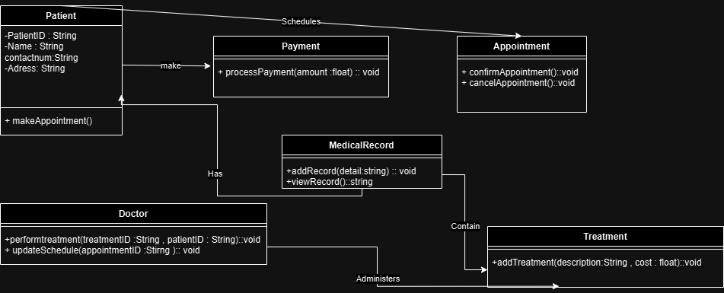

## Use Case Diagram

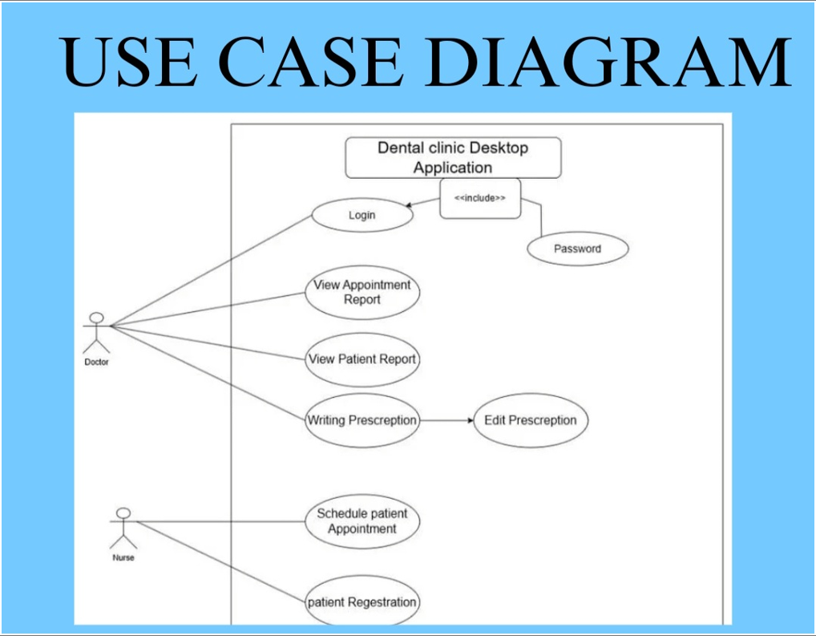

## Wireframe



